Chapter 3, Solution 65

For mesh 1,
–12 + 12I₁ – 6I₂ – I₄ = 0 or
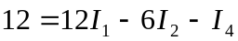 (1)
For mesh 2,
–6I₁ + 16I₂ – 8I₃ – I₄ – I₅ = 0 (2)
For mesh 3,
–8I₂ + 15I₃ – I₅ – 9 = 0 or
9 = –8I₂ + 15I₃ – I₅ (3)
For mesh 4,
–I₁ – I₂ + 7I₄ – 2I₅ – 6 = 0 or
6 = –I₁ – I₂ + 7I₄ – 2I₅ (4)
For mesh 5,
–I₂ – I₃ – 2I₄ + 8I₅ – 10 = 0 or
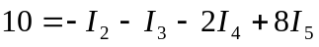 (5)
Casting (1) to (5) in matrix form gives
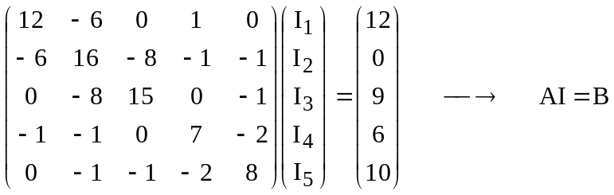

Using MATLAB we input:
Z=[12,-6,0,-1,0;-6,16,-8,-1,-1;0,-8,15,0,-1;-1,-1,0,7,-2;0,-1,-1,-2,8]
and V=[12;0;9;6;10]

This leads to
>> Z=[12,-6,0,-1,0;-6,16,-8,-1,-1;0,-8,15,0,-1;-1,-1,0,7,-2;0,-1,-1,-2,8]

Z =

12 -6 0 -1 0
-6 16 -8 -1 -1
0 -8 15 0 -1
-1 -1 0 7 -2
0 -1 -1 -2 8

>> V=[12;0;9;6;10]

V =

12
0
9
6
10

>> I=inv(Z)*V

I =

2.1701
1.9912
1.8119
2.0942
2.2489

Thus,
I = [2.17, 1.9912, 1.8119, 2.094, 2.249] A.

